Patient name: Clinic:

Patient age, gender: Dentist:

Date of check-list: Photo taken?:

Study model, whether there is an impression?:

1. CASE DISCRIPTION:
2. TOOTH COLOR, COLOR-MAP:

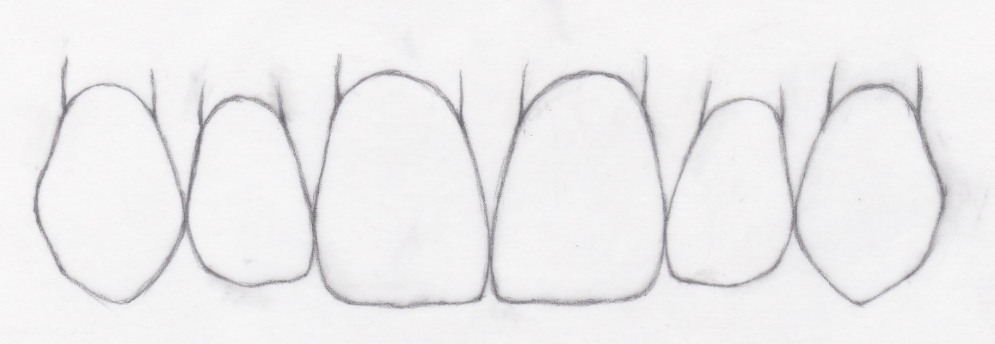

1. COLOR OF THE STUMP (For metal-free replacements)
2. BASIC SHAPE TYPE

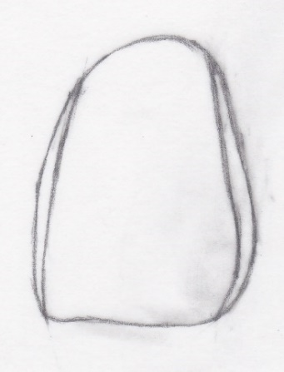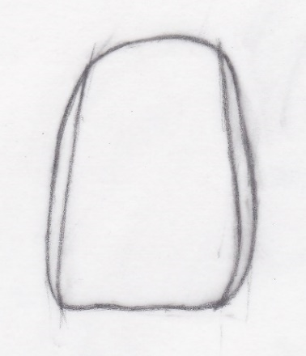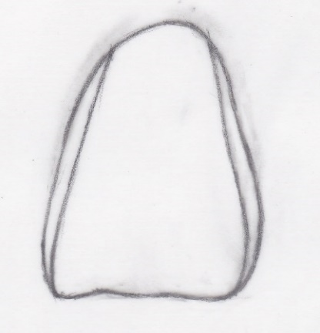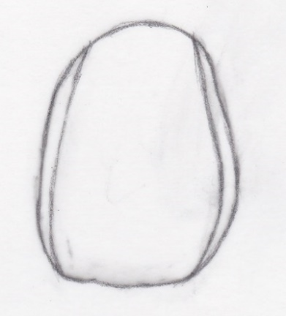

standard rectangular triangular oval

1. EDGE ABRASION

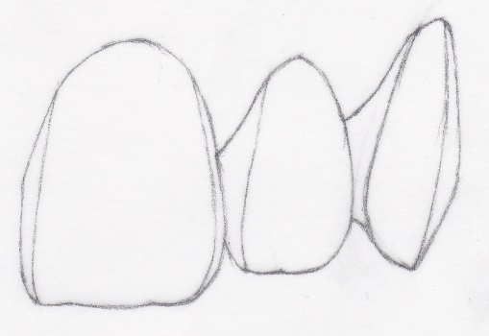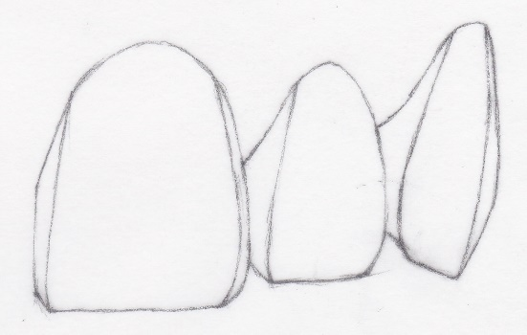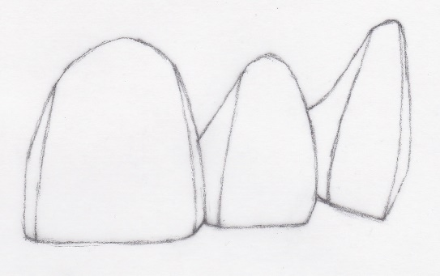

young small abrasion strong abrasion

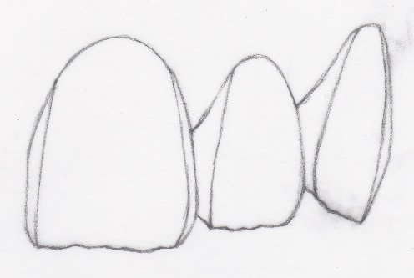

SHOULD THE ABRASION BE, CAN, NOT BE Lacy, uneven?

1. TEETH SURFACE TEXTURE

Smooth, medium, strongly textured, other

1. SYMMETRY

Should we strive for two-way symmetry? YES NO ANYTHING

1. POSITION, TILT, WRAP OF TEETH

a - Should we strive for regularity? YES NOT ANYTHING

b – If irregular, then e.g.:

1. OTHER INFORMATION, NEEDS

(Longer, more dominant large central incisors, very curved-edged lateral incisors, dominant canines, gum color… etc.)

***Dr. Maciej Zarow: Licówki – fantazia, ryzyko, sukces***

***Publisher: Quintessenz***